Science as a Human Endeavour (H)

In this strand, teaching and learning focuses on ‘why’ science matters and ‘who’ is involved in science. Students can be invited to consider the social, ethical
and environmental impacts of scientific work, and explore the roles of individuals and communities in scientific progress.

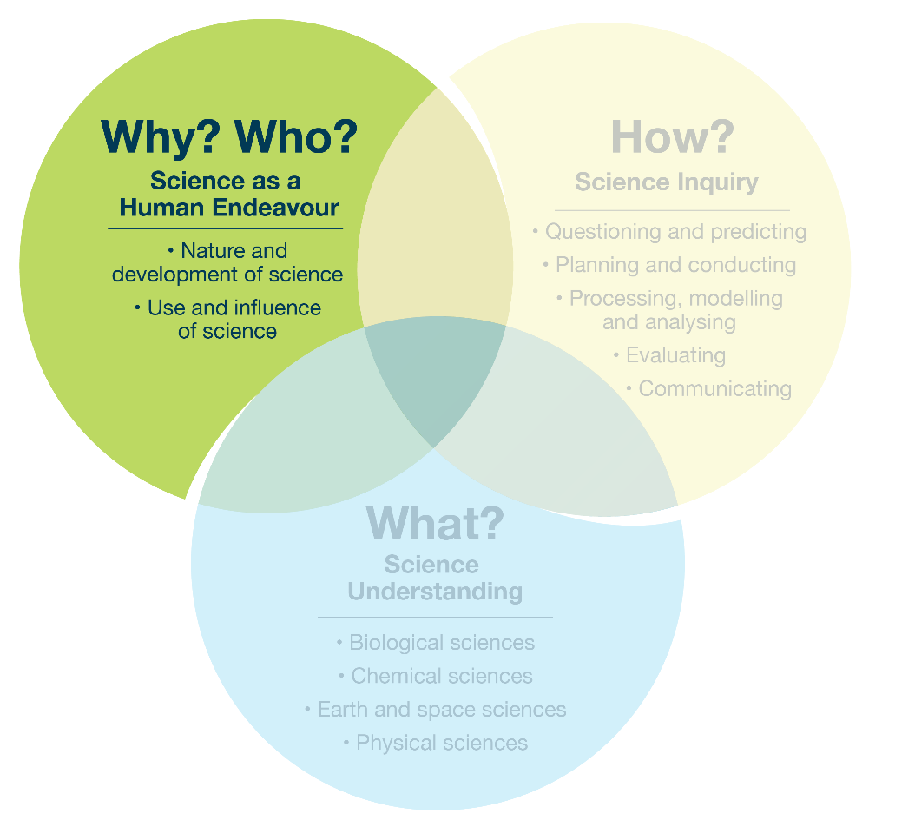
Focus 1.1 – The Science as a Human Endeavour strand and sub-strands

Example topic – single strand
Students might visit a local water treatment plant to learn about the process that makes tap water drinkable.
Possible focus questions | Curriculum alignment
Who is responsible for treating our local water supplies, and how do they make sure the water is safe to drink? | Use and influence of science: roles, responsibilities, decision-making, and application of science in the community
How do scientists and engineers use their knowledge of evaporation and condensation when designing systems to produce clean drinking water? | Use and influence of science: application of science to solve real-world problems
When was our local water treatment plant built, and what problem was it designed to solve for our community? | Nature and development of science: development of scientific knowledge and technologies over time to solve  a local community problem

